**Learn traditional skills**

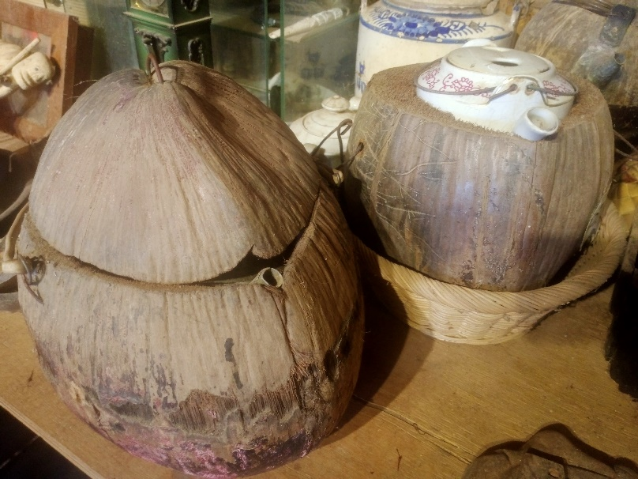We have a museum exhibit Cambodian traditional tools which used in their lifestyle. Many tools are not saw in Cambodian lifestyle anymore, and nobody knows how to use them. But we can learn knowledge of life from traditional equipment. For example, this is a tea pot with coconut. People understand the coconut can keep warm temperature, so they came up this way for tea pot. Like this we can learn lifeways from tools of traditional lifestyle.

Mr. Kom Sa Oung, he is one of people who try to keep Cambodian culture. He visited some villages to record the tools and lifestyle through interview the villagers. The exhibits in our museum are donated by his collections. Unfortunately, he passed away in 2021 but his spirit which want to inherit Cambodian worth culture to next generation is still in here, and Phum Asia and young students try to prohibit it.

